Lab 2: Adders/Subtractors

By Si Mai

CSC 342/343 Computer Organization

Professor Izidor Gertner

Spring 2017

Table of Contents

Objective 3

Functionality and Specification 4

Half Adder 4

Full-Adder Using Gates 6

Full-Adder using Half Adders as Components 8

Four-Bit Adder using One-Bit Full Adders as Components 10

Four Bit Subtractor using Four One Bit Full Adders as Components 11

Eight Bit Adder/Subtractor using Four Bit Subtractor as Components 13

Simulation 15

Half Adder 15

Full-Adder using Gates 15

Full-Adder using Half-Adders as Components 16

Four-Bit Adder using One-Bit Full Adders as Component 16

Four Bit Subtractor using Four Full Adders as Components 18

Eight Bit Adder/Subtractor using Four Bit Subtractors as Components 19

Implementation 20

Half Adder 20

Full Adder 23

Four-Bit Adder with Full Adders as Components 25

Four-Bit Subtractor using Full Adders as Components 27

Eight-Bit Adder/Subtractor 28

Conclusion 32

# Objective

The objective of this lab is to understand how adders work for binary numbers. The student  
must master how to add binary numbers by using the carry rule. This will enable the student to  
understand how the half and full adders work, and the similarities and differences between them. Next  
the student will program the half and full adders in ModelSim in VHDL language. The student must verify that the circuits work correctly for all possible values using test benches and show the circuit designs’ correctness via waveform simulation. After that the student will implement these half adder and full adder circuit designs onto the DE2-70 board to test for correctness. Once this is done the student will further extend his knowledge of adders by utilizing the one-bit full adder to implement the four-bit full adder. Next the student will use the full adder to implement the four-bit subtractor. Finally, the student will create an eight bit adder/subtractor using the four-bit subtractor. At the end of this lab the student will understand how to implement an adder and subtractor for an arbitrary number of bits.

# Functionality and Specification

## Half Adder

The half adder is a circuit that takes in two bits and outputs the sum and carry bits. For a visual representation, see Fig. 1 below. The x and y each take on two possible values, for a total of four input combinations. The corresponding output is shown below the line. An equivalent way of representing

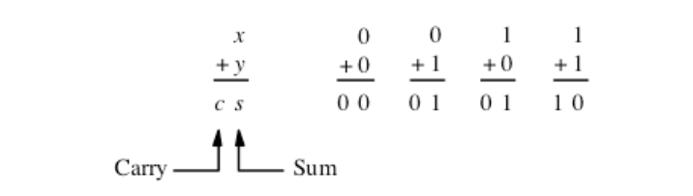

Fig. 1. Half Adder using Arithmetic

Fig. 1 is through the truth table, as shown on Table I. The carry bit is 1 when both x and y are 1, and 0 otherwise. The sum is 1 when x and y are not equal. From the truth table we can create a circuit diagram for the half adder with an AND and XOR gate for the carry and sum bits respectively.

Table I. Truth Table of Half Adder

|  |  |  |  |
| --- | --- | --- | --- |
| Input | | Output | |
| X | **Y** | **Carry** | **Sum** |
| 0 | 0 | 0 | 0 |
| 0 | 1 | 0 | 1 |
| 1 | 0 | 0 | 1 |
| 1 | 1 | 1 | 0 |

Fig. 2 shows the circuit diagram for the half adder. The x and y are inputs to both the AND and XOR gate.

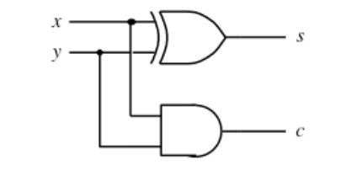

Fig. 2. Half Adder Circuit Diagram.

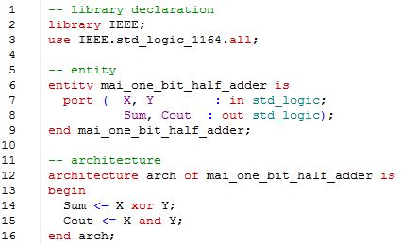

Fig. 3. VHDL Code for Half Adder.

## Full-Adder Using Gates

The full adder includes a carry in (shortened to Cin) whereas the half adder does not. With three  
inputs, there are eight possible combinations. Table II shows the truth table with the inputs and outputs.

Table II. Truth Table for Full Adder

|  |  |  |  |  |
| --- | --- | --- | --- | --- |
| Input | | | Output | |
| X | **Y** | **Cin** | **EQ** | **EQNOT** |
| 0 | 0 | 0 | 1 | 0 |
| 0 | 0 | 0 | 0 | 1 |
| 0 | 0 | 1 | 0 | 1 |
| 0 | 0 | 1 | 0 | 1 |
| 0 | 1 | 0 | 0 | 1 |
| 0 | 1 | 0 | 1 | 0 |
| 0 | 1 | 1 | 0 | 1 |
| 0 | 1 | 1 | 0 | 1 |

From the truth table above, we can derive the circuit design of the full adder implemented only with  
gates. Fig. 4 shows the circuit diagram of the full adder designed with gates. The sum is an exclusive or  
between the three input bits. The circuit design for the carry out is implemented by using K-maps to  
reduce the sum of standard products into a sum of products, each consisting of two literals. Using the  
data-flow model, we can directly map the circuit design into VHDL code, which is shown on Fig. 5.

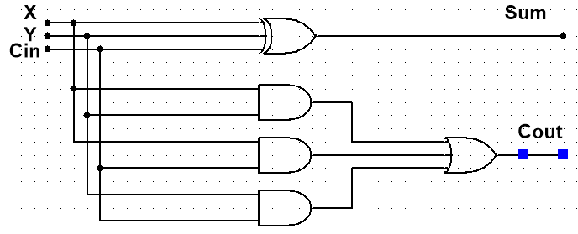

Fig. 4. Circuit Diagram for Full Adder with Gates

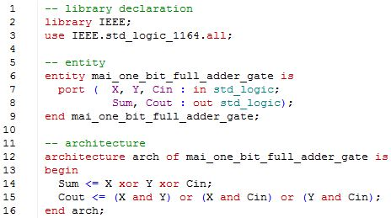

Fig. 5. VHDL Code for Full Adder with Gates.

## Full-Adder using Half Adders as Components

An alternate way of designing the full adder is to use two half adders. Fig. 6 shows circuit design  
of the full adder using said design mentioned above. Since we have created the VHDL code for the half  
adder, we can encapsulate the XOR and AND gates within black boxes in Fig. 6 and call it HA1 and HA2 to  
represent the first and second half adder respectively. The circuit diagrams in Fig. 6 and Fig. 7 are  
equivalent. With Fig. 7, we are now ready to create the VHDL code for the full adder using structural  
modeling, which is shown on Fig. 8. 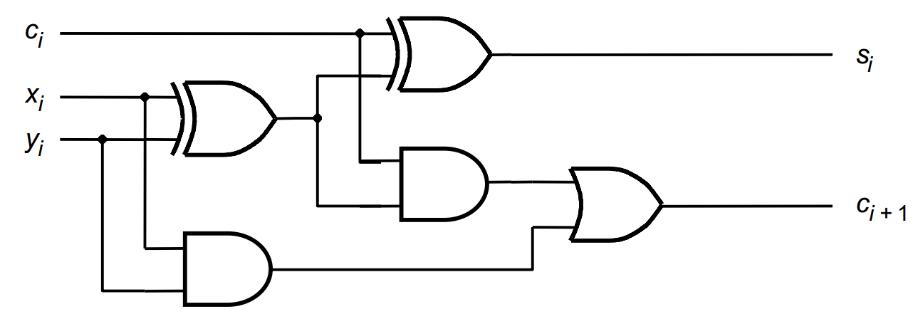

Fig. 6. Circuit Diagram of Full Adder with Half Adders as Components (gates).

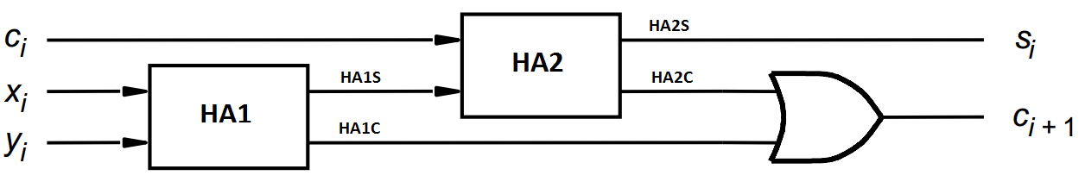

Fig. 7. Circuit Diagram of Full Adder with Half Adders as Components (Block Diagram).

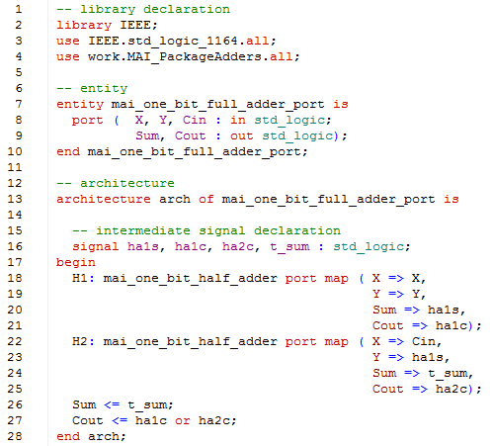

Fig. 8. VHDL Code for Full Adder using Half Adders as Components.

In Fig. 8 we declared the use of the half adder by calling the MAI_PackageAdders on line 4, where the component is stored. Then we use the components on 18 and 22, using the keywords **port map**. The => assignment is used to map the inputs of the full adder and the intermediate signals to the external ports of the half adders. Structural modeling allows for reuse of code. This is better than the data flow model because checking for error and code readability are better.

## Four-Bit Adder using One-Bit Full Adders as Components

Now that we have created the one-bit full adders, we can extend these full adders and create a  
four-bit full adder. The VHDL code is shown on Fig. 9. The external signals to the four-bit full adder is  
declared from line 7 to line 10: input vectors X and Y, single bit Cin, output vector Sum and single bit  
Cout. The one-bit full adder is declared as a component on lines 17 to 20. The four-bit full adder is  
implemented by using four one-bit full adders. The intermediate signals c(2) and c(1) are used to hold  
the carry outs from one full adder to be used as the carry ins to another full adder

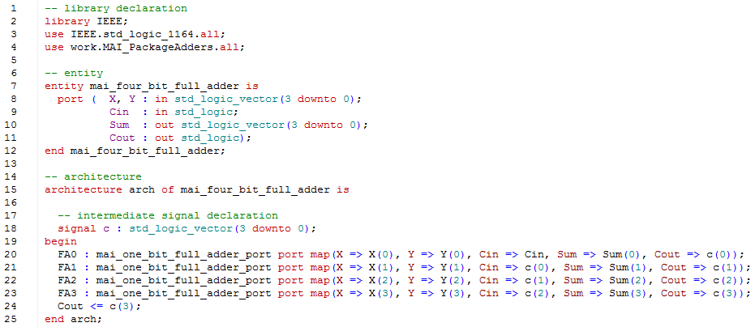

Fig. 9. VHL Code for Four-Bit Adder using One-Bit Full Adders as Components.

## Four Bit Subtractor using Four One Bit Full Adders as Components

The four bit subtractor is shown below in Fig. 10. The inputs are the signed four bit binary X and Y, and the outputs are the Sum (another signed vector of four bits), Overflow, Negative, and Zero bits. Subtraction between two binary numbers is done by adding the inverse of the second operand.

$$X-Y=X+(-Y)$$

Binary numbers can represent negative numbers through a mathematical operation known as the Two’s Complement. In the case above, Y is complemented by inverting all the 0s and 1s into 1s and 0s respectively. In Fig. 10, this is done by the inverters. Then Y is increased by 1, which is done by passing 1 into c0 for the first full adder in the circuit below. The overflow bit is determined by looking at the two highest carry out bits. If the most significant bit (MSB) of the sum is 1, then the negative output is 1. For the zero bit to be set, all the binary digits of the sum must be 0.

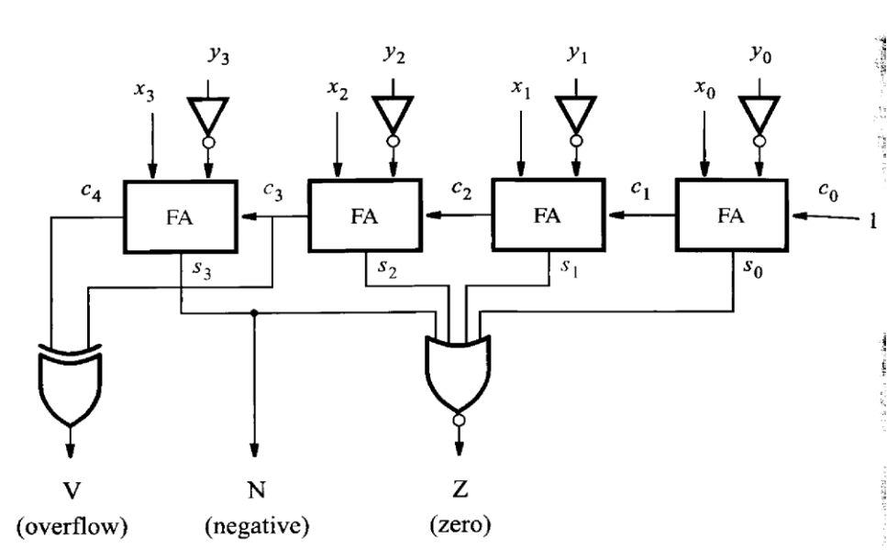

Fig. 10. Schematic of a four bit subtractor using four one bit full adders as components.

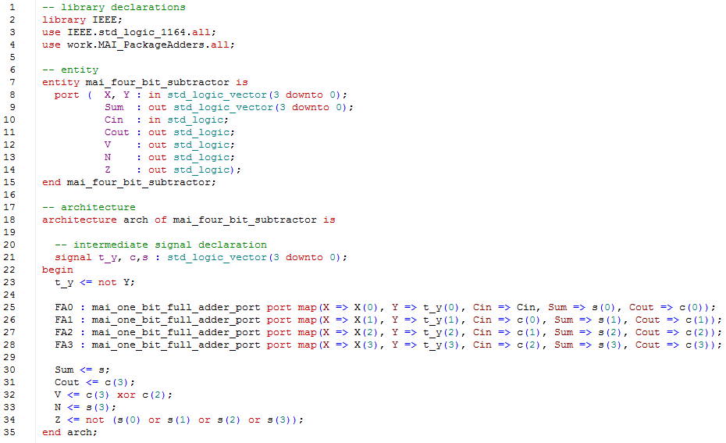

Fig. 11. VHDL code for four bit subtractor using one bit full adders as components.

The VHDL for the four bit subtractor is shown above in Fig. 11. Four one bit full adders are used to create the four bit subtractor. The input signal variable Cin on line 10 is C0 in Fig. 10. Cin is not set to 1 as shown in Fig. 10 because it prevents the four bit subtractor from being used to create a higher bit subtractor.

## Eight Bit Adder/Subtractor using Four Bit Subtractor as Components

With the four bit subtractor completed, we can easily implement the eight bit adder/subtractor unit. This is done by using one multiplexer and two four bit subtractors. In Fig. 12, we use a multiplexer to decide whether to add or subtract. The VHDL code for the multiplexer is shown in Fig. 13. When the

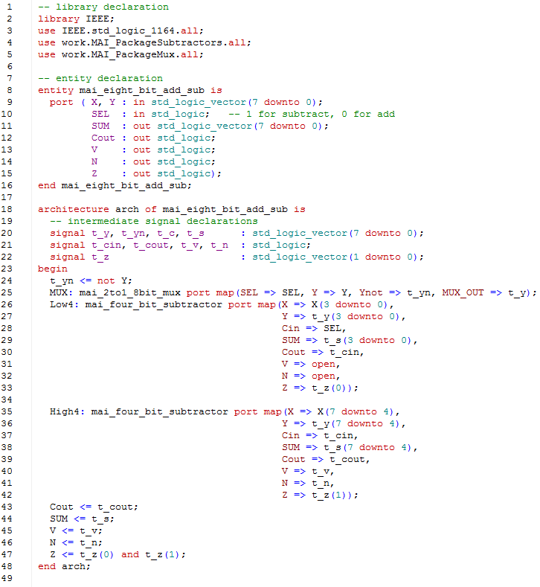

Fig. 12. VHDL code for eight bit adder/subtractor using the four bit subtractor as components.

multiplexer switch (called SEL in the code) is set to 1, Y is passed as the output. The switch also sets the carry in of the leftmost four bit subtractor to 1. As explained in the previous section, this completes the Two’s Complement of Y, because Y is complemented inside the four bit subtractors and increased by 1. When the multiplexer is set to 0, the complement of Y is passed as the output and is complemented again inside the four bit subtractors.

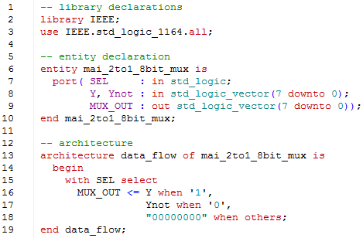

Fig. 13. VHDL code for the multiplexer.

# Simulation

## Half Adder

The simulation of the half adder is shown on Fig. 10. Since the half adder uses two inputs, there  
are four possible combinations. These combinations were manually tested in ModelSim. First input was  
0+0, which gave output a sum of 0 and a carry out of 0. The next input was 1+0, which output a sum of 1  
and a carry out of 0. Then the input was 0+1, which the sum and carry out as the same as the previous  
input. Lastly, the addition of 1+1 gave a sum of 1 and a carry out of 0. These input-output combinations  
matched what was on the truth table and thus the half adder VHDL code is verified as correct.

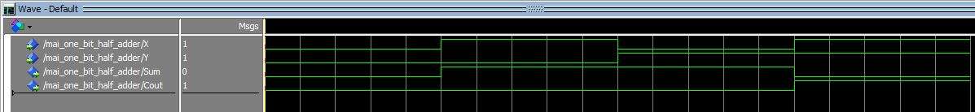

Fig. 14. Simulation of the Half Adder.

## Full-Adder using Gates

The simulation of the full adder is shown on Fig. 11. The full adder uses three inputs for eight  
possible combinations. Rather than manually forcing the inputs of X, Y and Cin and running the  
simulation for 100 ns, a test bench, shown in Fig. 16, was created to run the eight possible inputs. t_x and t_y are the intermediate signals that hold the X and Y bits. t_cin holds the Cin bit. Lastly, the t_out signal holds the sum and carry out bits, with the carry out being the most significant bit and the sum as the least significant bit. As we can see, the error signal is 0 throughout the simulation, which indicates that the full adder implemented with gates works correctly.

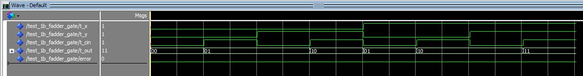

Fig. 15. Simulation of the Full Adder implemented with Gates

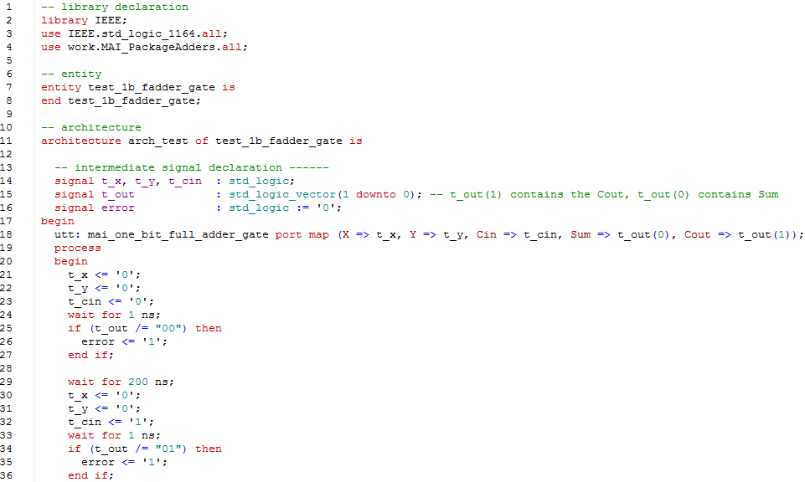

Fig. 16. Portion of the test code for the full adder using gates.

## Full-Adder using Half-Adders as Components

The simulation of the full adder using half-adders as components was done with the same test bench above. No code changes were necessary because the component is included on line 4. Below shows the eight possible inputs and the corresponding outputs. The error signal is again 0 for the duration of the simulation. This means that the circuit design works as intended.

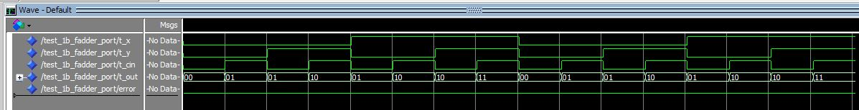

Fig. 17. Simulation of the Full Adder using Half Adders as Components.

## Four-Bit Adder using One-Bit Full Adders as Component

The simulation of the four-bit adder is done with a test bench, shown on Fig. 19. With nine total bits as inputs, manually setting all the possible combinations in the test bench would take too long. Thus, the test bench uses two for loops, on lines 31 and 33, to iterate all the possible combinations and checks the t_sum against the sum calculated by the simulation. As we can see in the simulation below, the error signal never switches from 0 to 1, which shows that the full adder circuit design is correct.



Fig. 18. Simulation of the Four-Bit Adder using One-Bit Full Adders as Components

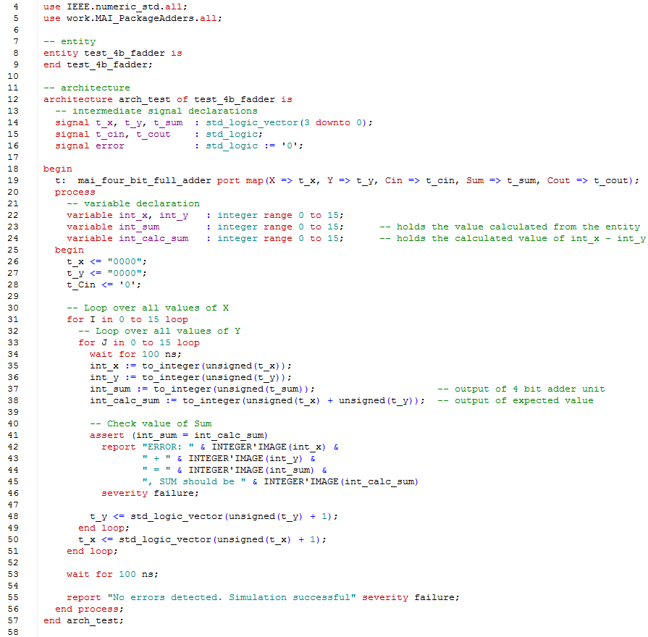

Fig. 19. VHDL test code for the four bit full adder.

## Four Bit Subtractor using Four Full Adders as Components

The four bit subtractor was simulated in ModelSim using the test bench below. With two four bit inputs, there are 255 different combinations. Therefore two four loops were used, on line 31 and 32. Then then output of the four bit subtractor is tested against what the actual output should be given two inputs. If they were not the same, then an error had occurred. Fig. 20 shows the simulated waveform of the four bit subtractor.

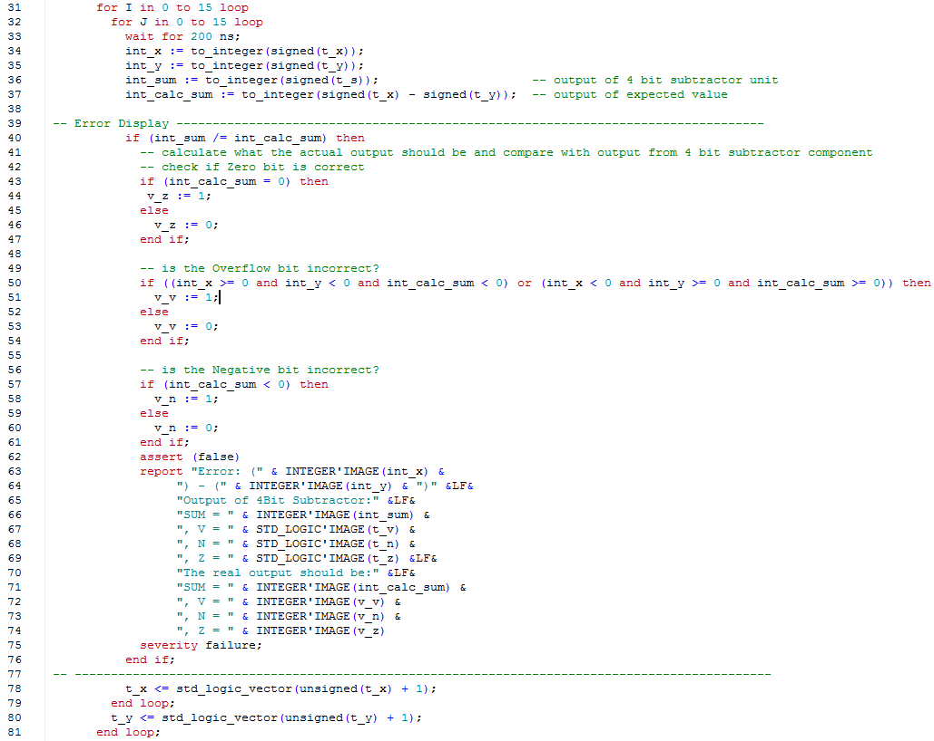

Fig. 19. VHDL test bench for four bit subtractor.



Fig. 20. Simulation of the four bit subtractor.

## Eight Bit Adder/Subtractor using Four Bit Subtractors as Components

Having confirmed that the four bit subtractor works correctly, we can now use it to create the eight bit adder/subtractor. A portion of the test bench for the unit is shown in Fig. 21. First the input vectors are converted into signed vectors so that they can be represented as integers. Then the calculated sum (or difference) is compared with the output from the adder/subtractor component. If they are not equal, then the test bench exists with an error showing the outputs of the adder/subtractor and what the real outputs should be. The waveform in Fig. 22 shows all the possible inputs and their corresponding outputs. Thus the simulation of the component is complete and the unit works correctly.

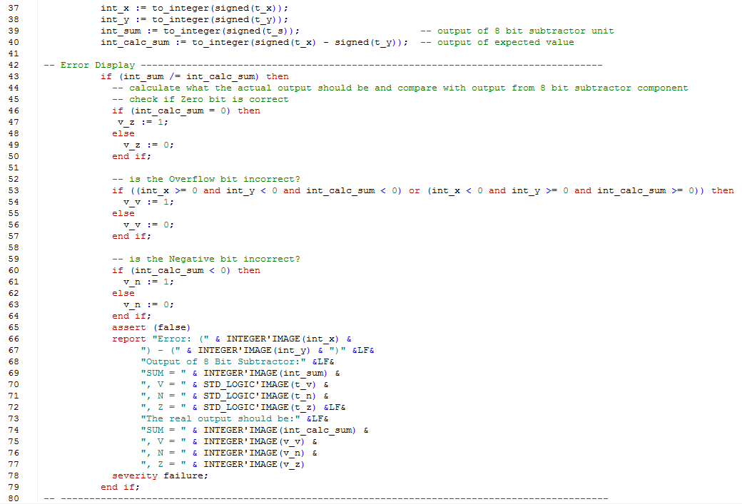

Fig. 21. VHDL test bench for eight bit adder/subtractor.



Fig. 22. Output waveform of the eight bit adder/subtractor unit.

# Implementation

## Half Adder

The testing of the half adder is show on Fig. 23. The switches SW0 and SW1 are used for X and Y  
respectively. LEDs LEDR0 and LEDR1 are used for the Sum and Cout respectively. Fig. 14 shows the  
addition of 0 + 0, which leads to a sum and carry out of both 0. Neither LEDs light up, which is correct.

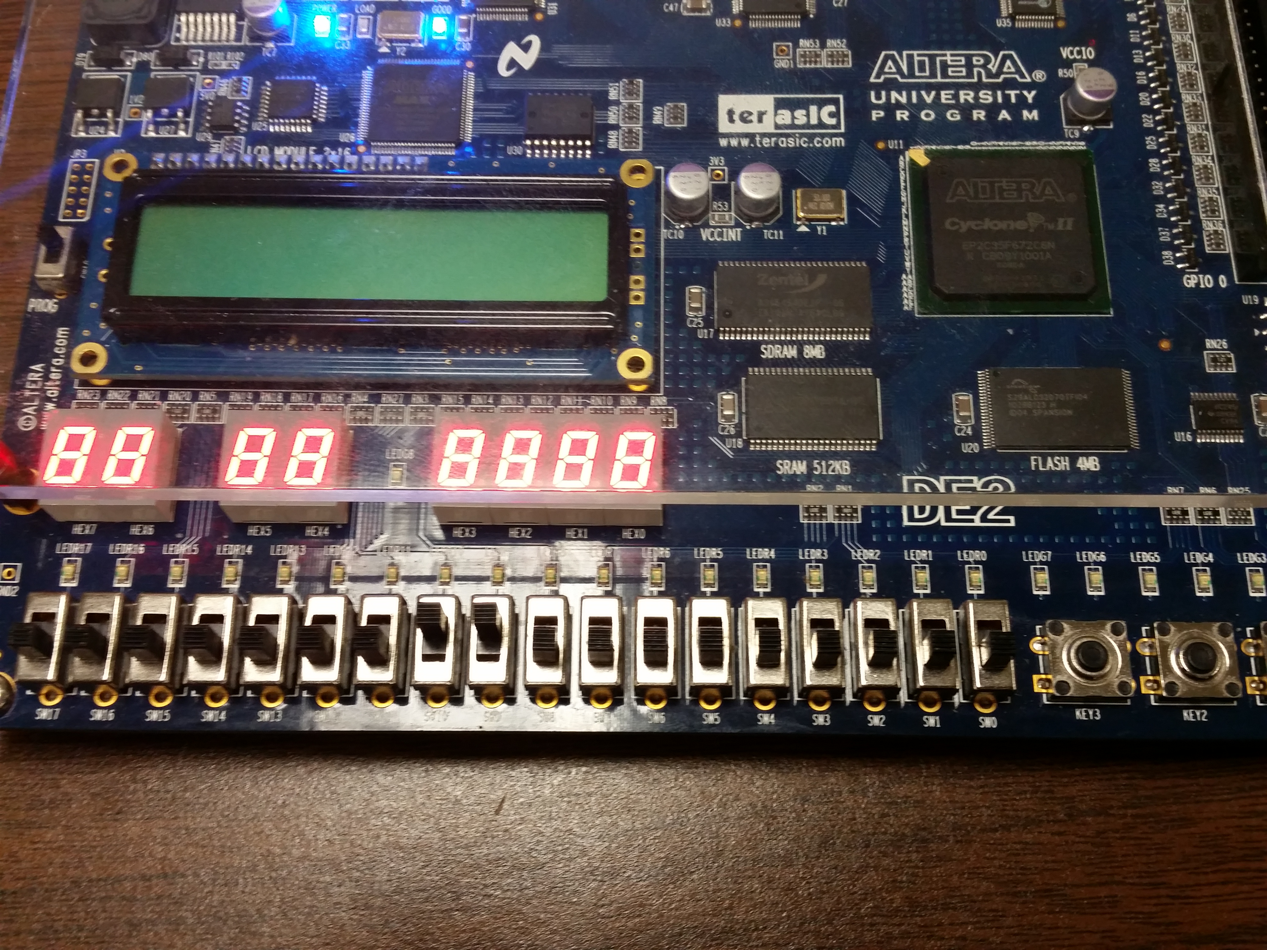

Fig. 23. One-Bit Half Adder on the DE2-70 Board.

Fig. 24 and Fig. 25 on the next page show the addition of 0 + 1 and vice versa. In both figures, the  
addition only lights up the LED for sum and the carry out remains unlit.

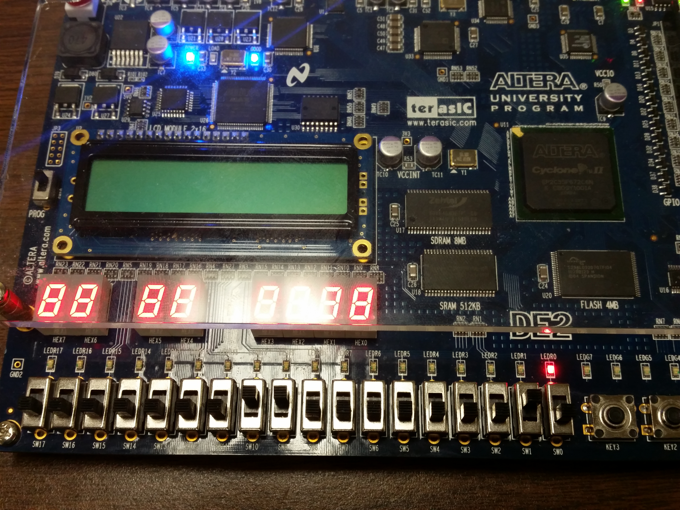

Fig. 24. Addition of 1 + 0. The sum is 1 and carry out is 0.

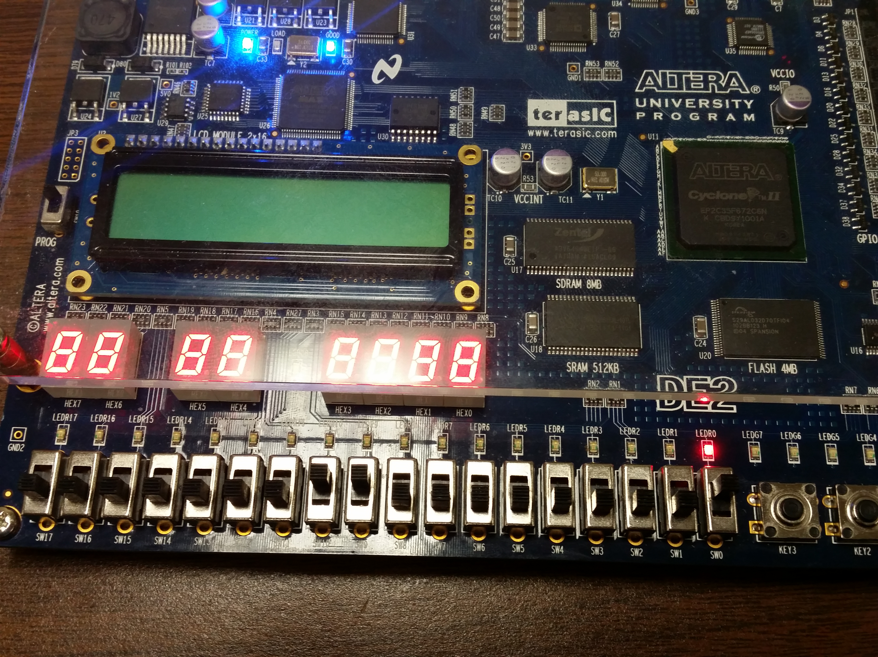

Fig. 25. Addition of 0 + 1. The sum is 1 and carry out is 0.

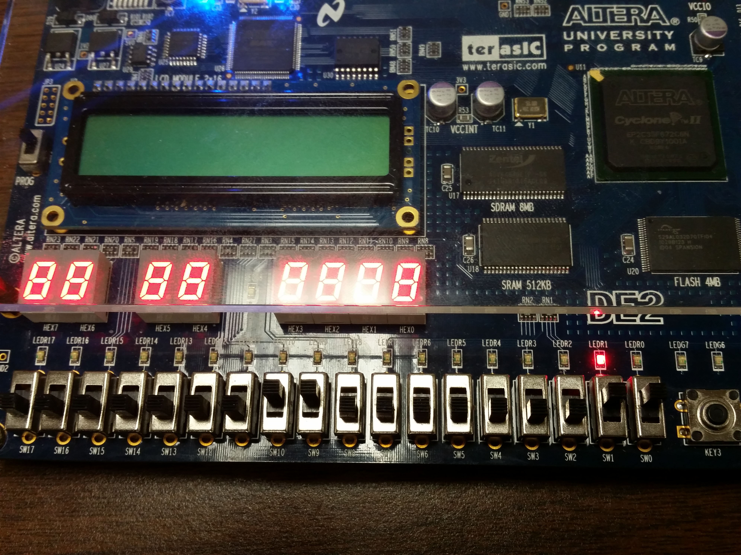

Fig. 26. Addition of 1+1. The carry out is lit, but the sum is not.

In Fig. 26, both X and Y are 1, so the addition gives the output 1 and 0 for the sum and carry out bit.

## Full Adder

For the full adder, switches LEDR0 and LEDR1 are used for the sum and carry out bit. The  
switches SW0, SW1, and SW2 are used for the carry in, X, and Y bits. Fig. 27 shows the addition with the  
inputs all set to 1. The full adder circuit sets the carry out and sum to 1, which is also shown on the  
board below.

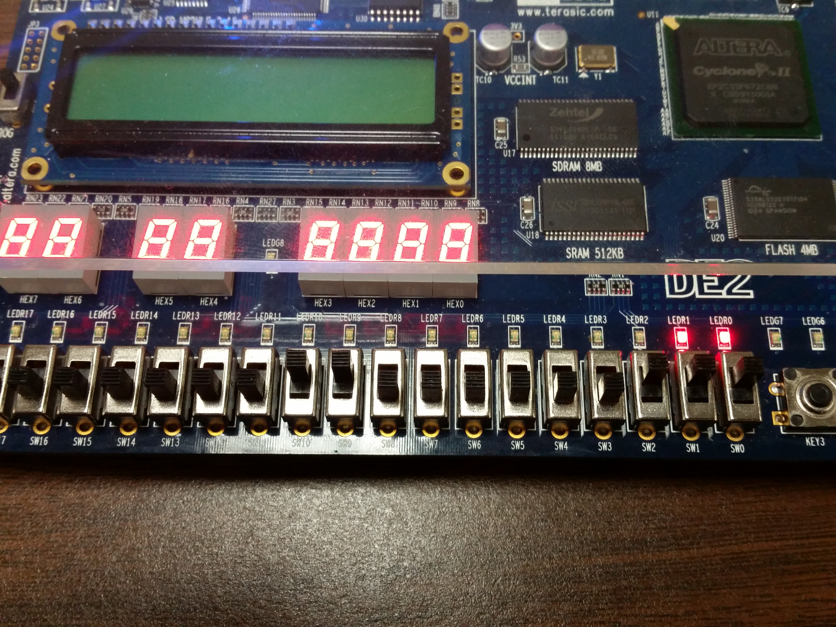

Fig. 27. Full Adder with X, Y and Cin set to 1. The output is 11.

In Fig. 28 and 29 show some addition tests using the full adder circuit design. In both cases, the output  
was correct. More tests was done manually, and although they are not shown below, the  
implementation of the full adder with gates and half adders as components worked correctly.

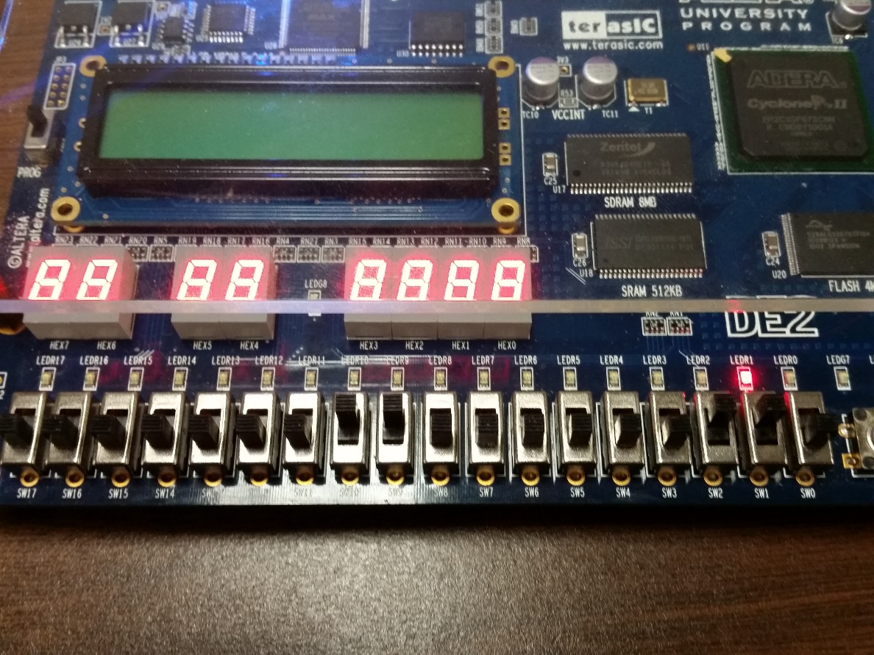

Fig. 28. Full adder. X and Y are set to 1, and carry in is set to 0. This outputs 1 to carry out and 0 to sum.

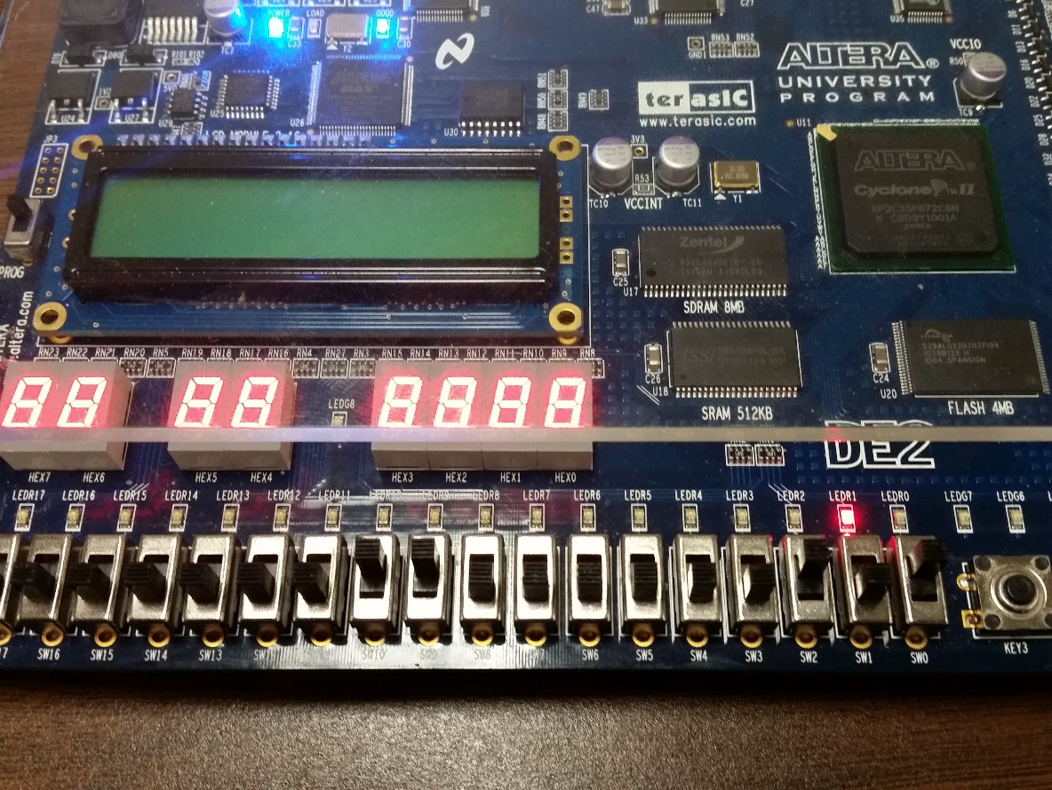

Fig. 29. Four bit full adder. The addition of 0+1+0 yields 1 on the LEDs.

## Four-Bit Adder with Full Adders as Components

The implementation of the four-bit full adder is shown on Fig. 30. The inputs are controlled by  
the switches. The paper columns delineate the three inputs (from left to right); Cin, X, and Y. X and Y are  
both four bit binary numbers where the leftmost bit is the most significant bit and the rightmost bit is  
the least significant bit. The output is shown in binary with the LEDs from LEDR0 to LEDR4. The rightmost  
LED represents Cout and the rest of the LEDs to the right of the carry out represent the four bit binary  
number sum. Fig. 21 shows the addition of 0 + 1 + 0, which outputs the value of 1 in the LEDs.

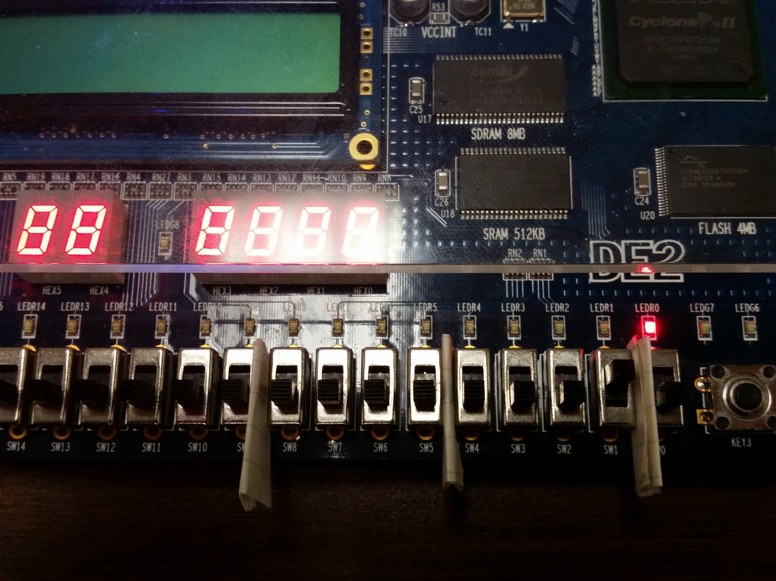

Fig. 30. Four bit full adder. The addition of 0+1+0 yields 1 on the LEDs.

In Fig. 31, we changed the value of Y from 0 to 1 and the sum output the value of 2. For further tests, watch the video on the four-bit full adder.

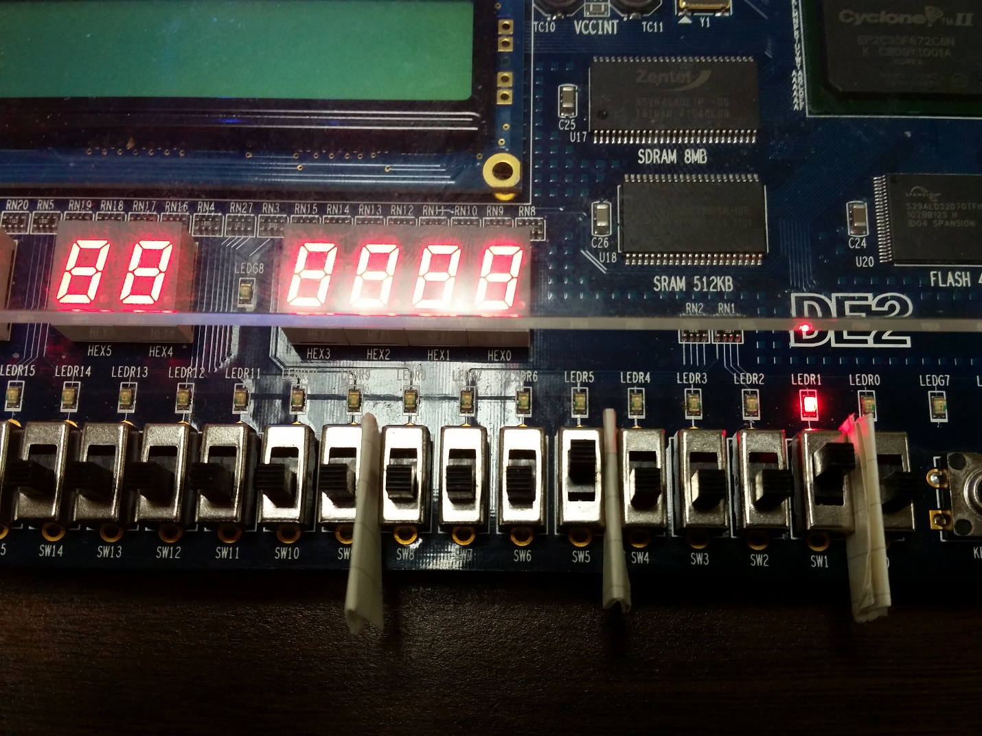

Fig. 31. Addition of 1+1+0, which outputs the value of 2 in the sum.

## Four-Bit Subtractor using Full Adders as Components

The implementation of the signed four-bit subtractor is shown on Fig. 32. The switches SW7 – SW4 and SW3 – SW0 represent the left and right operands respectively. LEDs LEDR3 – LEDR0 represents the sum in binary. The overflow, negative, and zero bits are represented by the LEDs LEDR7 – LEDR5 respectively. In Fig. 32, -4 is subtracted from 7. The output should be 11; however, the range of a signed four bit binary number is from -8 to 7. Therefore the sum is signed and is -5 instead. The overflow and negative bits light up accordingly.

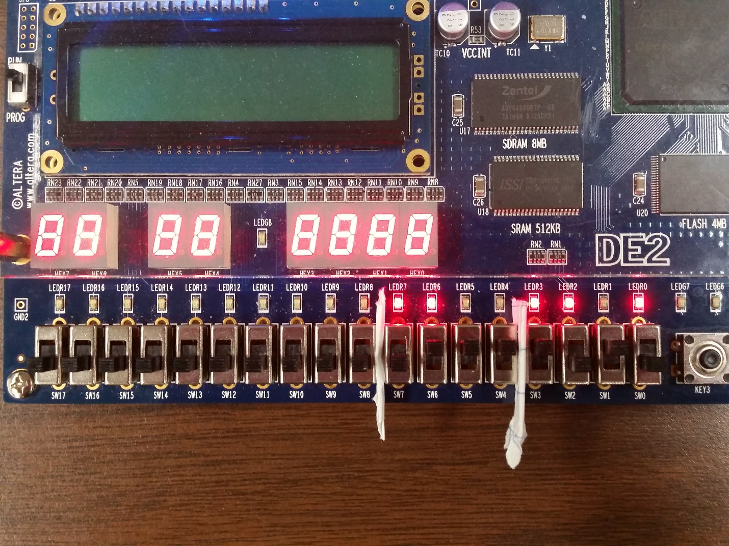

Fig. 32. Four bit subtractor on the DE2 board. 7 - (-4) = -5. The Overflow and Negative bits are lit.

## Eight-Bit Adder/Subtractor

The implementation of the signed eight-bit adder/subtractor is shown in Fig. 33. The switches SW15 – SW8 and SW7 – SW0 represent the left and right operands respectively. The switch controlling whether the operation is addition or subtraction is SW17, on the left end of the DE2 board. LEDR7 – LEDR0 represents the eight bit sum. The overflow, negative, and zero bits are located on the right side of the board with LEDG2 to LEDG0 respectively. The picture also shows LEDR15 lighting up. This is due a short circuit somewhere in the board. Fig. 33 shows the subtraction of 127 and 127. The sum is 0 and the zero bit is lit. In Fig. 34, SW17 is switched off, so 127 is added to 127. This leads to an overflow because the range of an eight-bit binary number is from -128 to 127. Therefore the signed representation of the sum is -2 instead of 254 in unsigned.

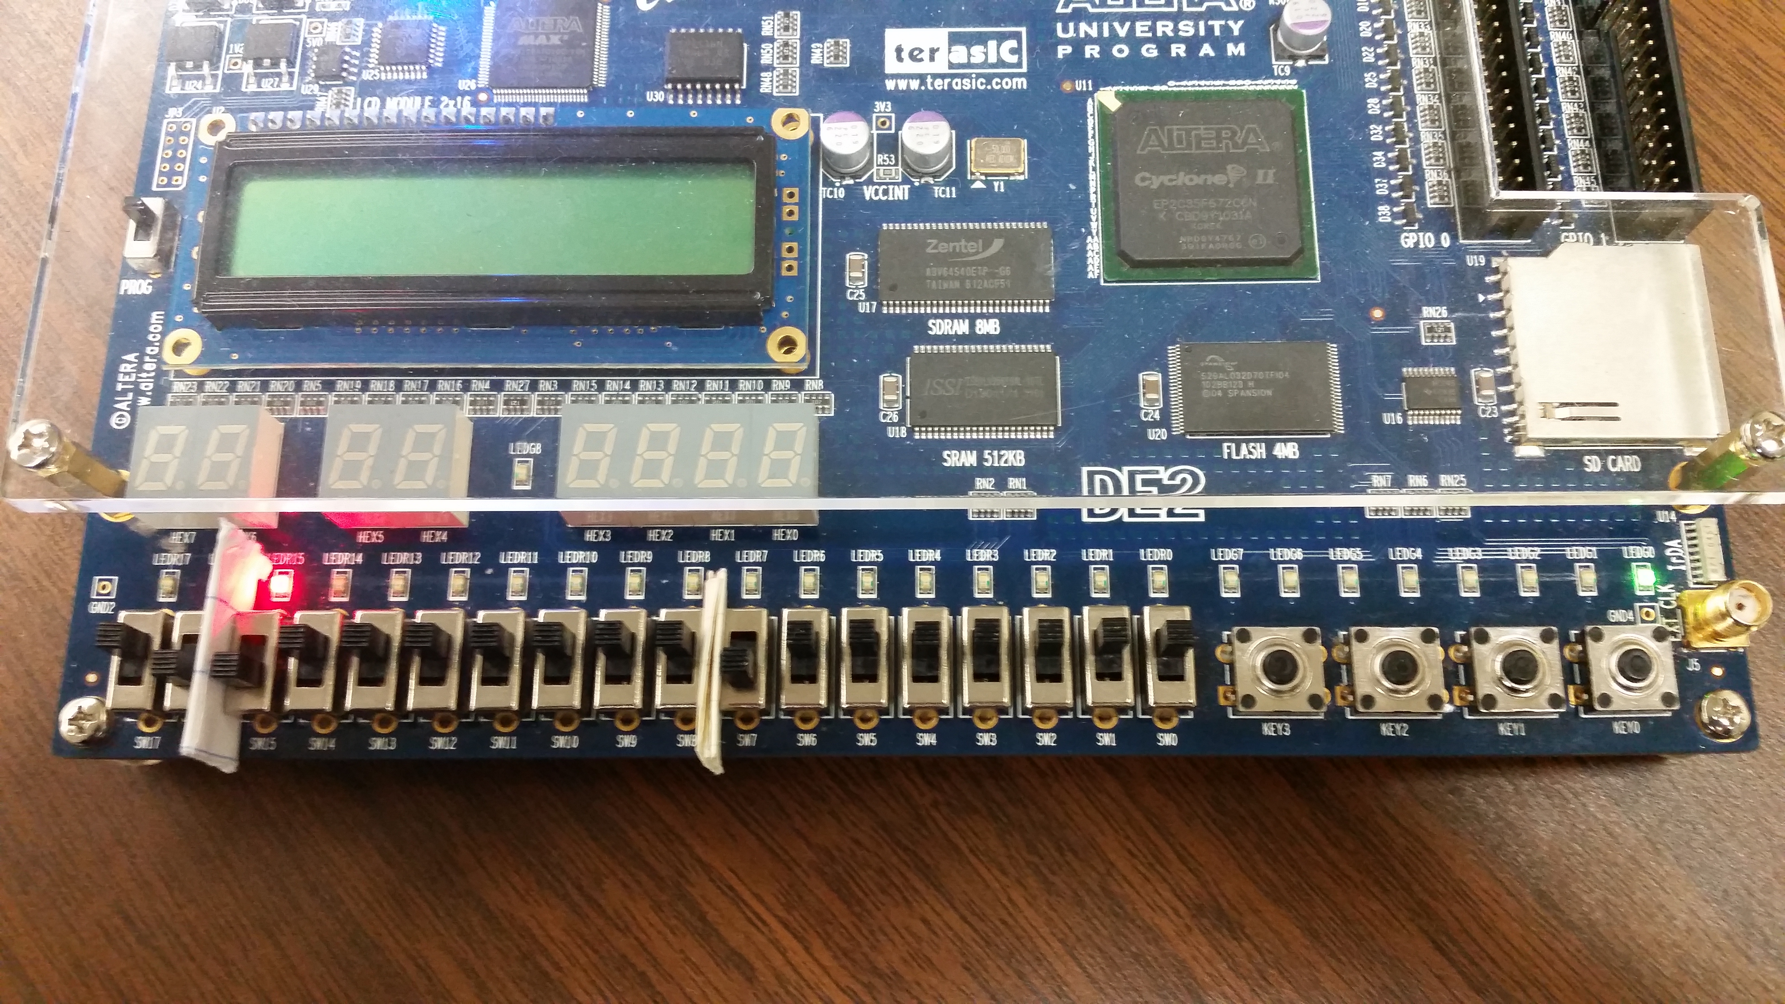

Fig. 33. Eight-bit adder/subtractor. The subtraction of 127 and127 is 0. The zero bit on LEDG0 lights up accordingly.

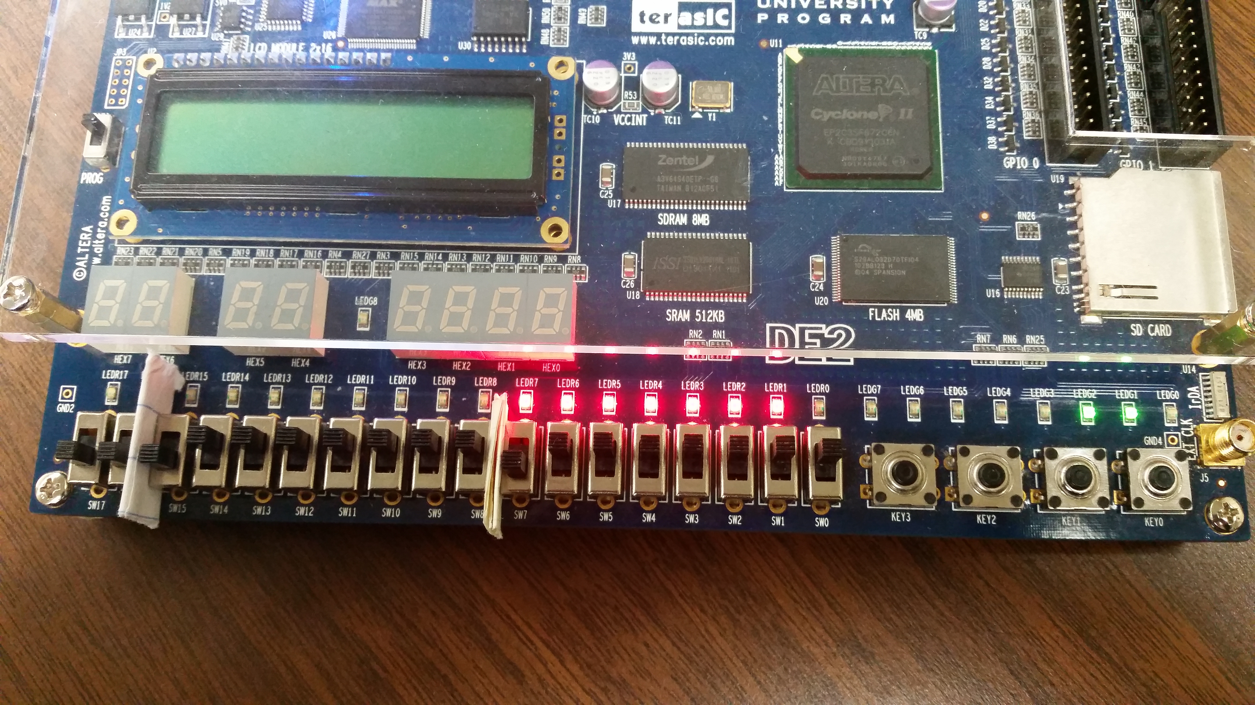

Fig. 34. Addition of 127 and 127. This is an overflow because a signed 8 bit binary ranges from -128 to 127.

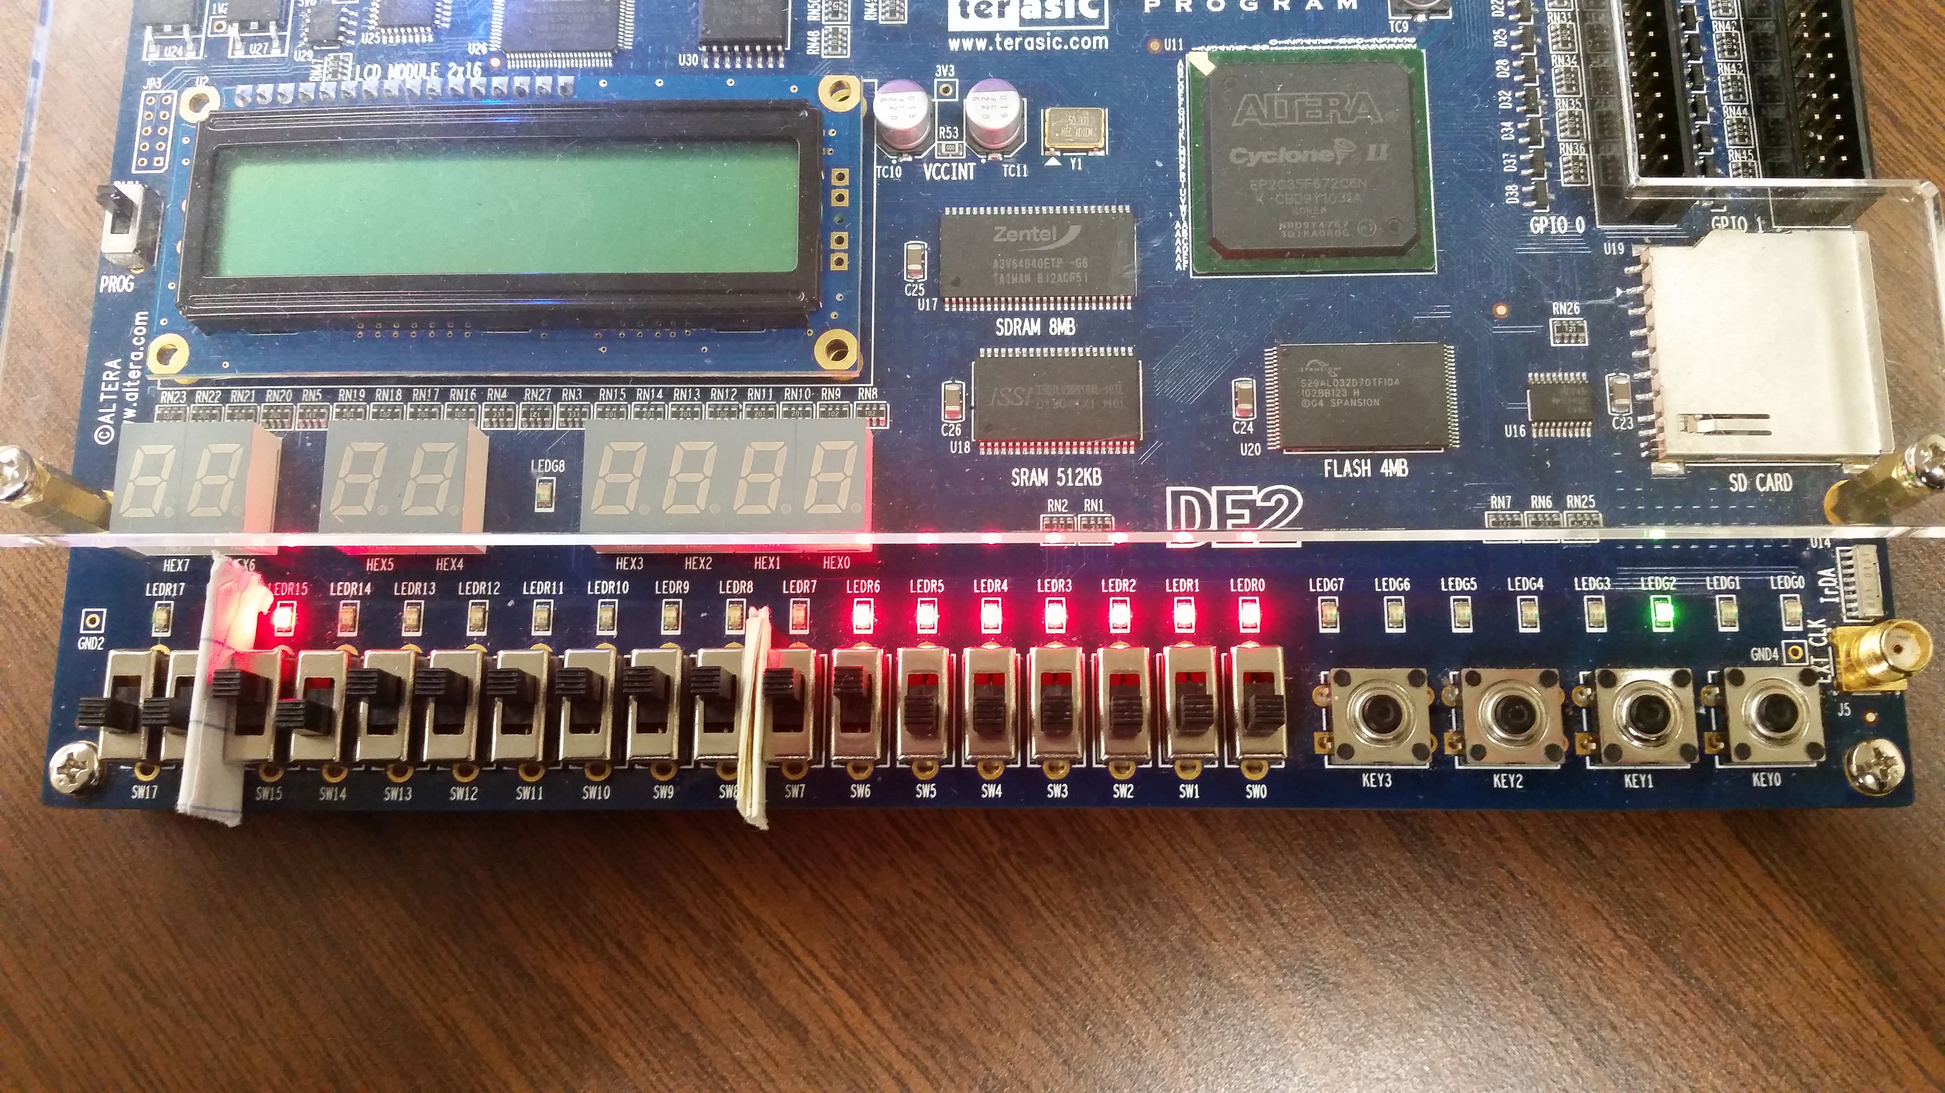

Fig. 35. -65+-64 results in 127 instead of -129, which is an overflow.

In Fig. 35, we add -64 to -65. This leads to another overflow, since the addition of two negatives should be negative. Instead, we get a result of 127. Fig. 36 and 37 show other cases of overflow.

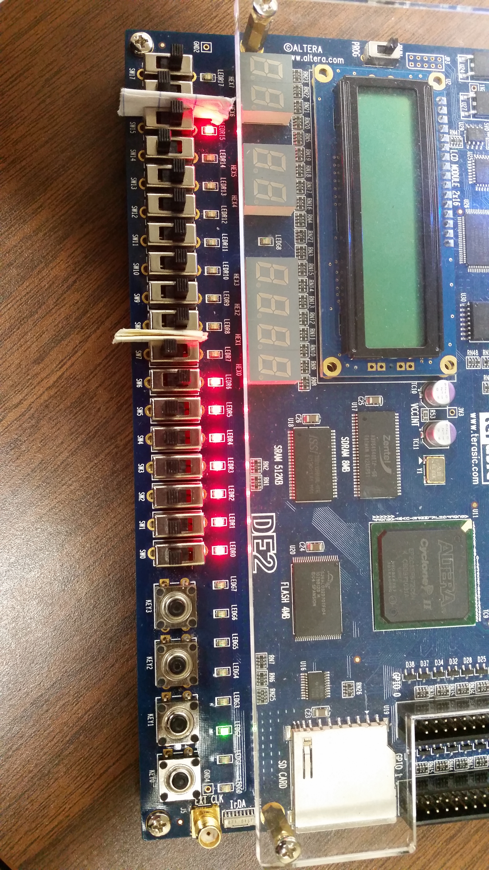

Fig. 36. -65- 64 also leads to another overflow. The output is again 127.

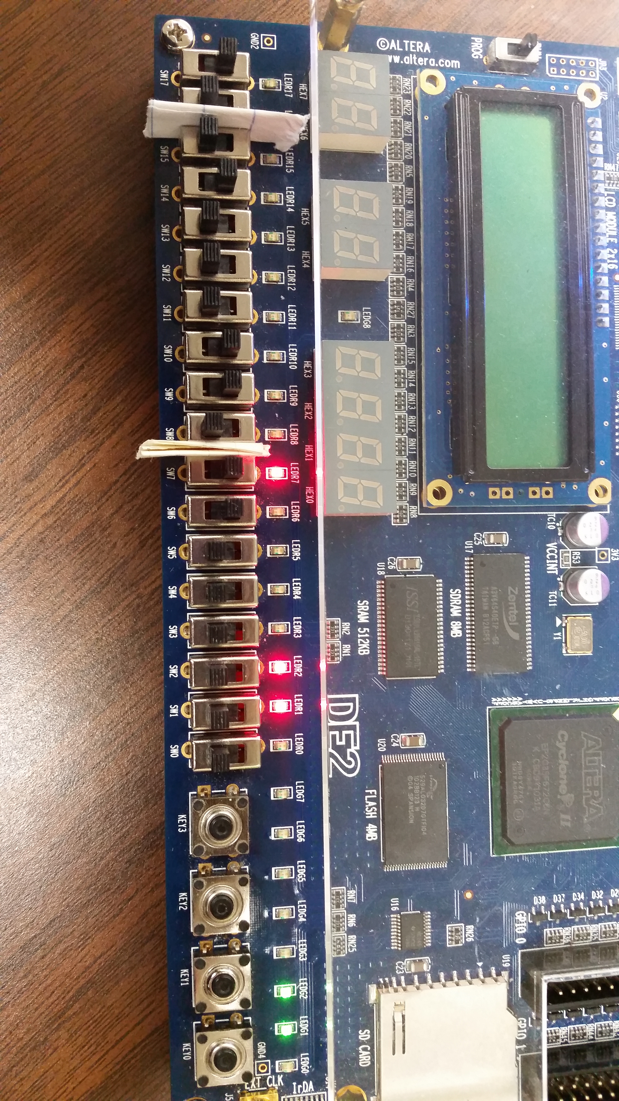

Fig. 37. 70 - (-64) gives -122, which is another overflow. The overflow and negative bits are lit.

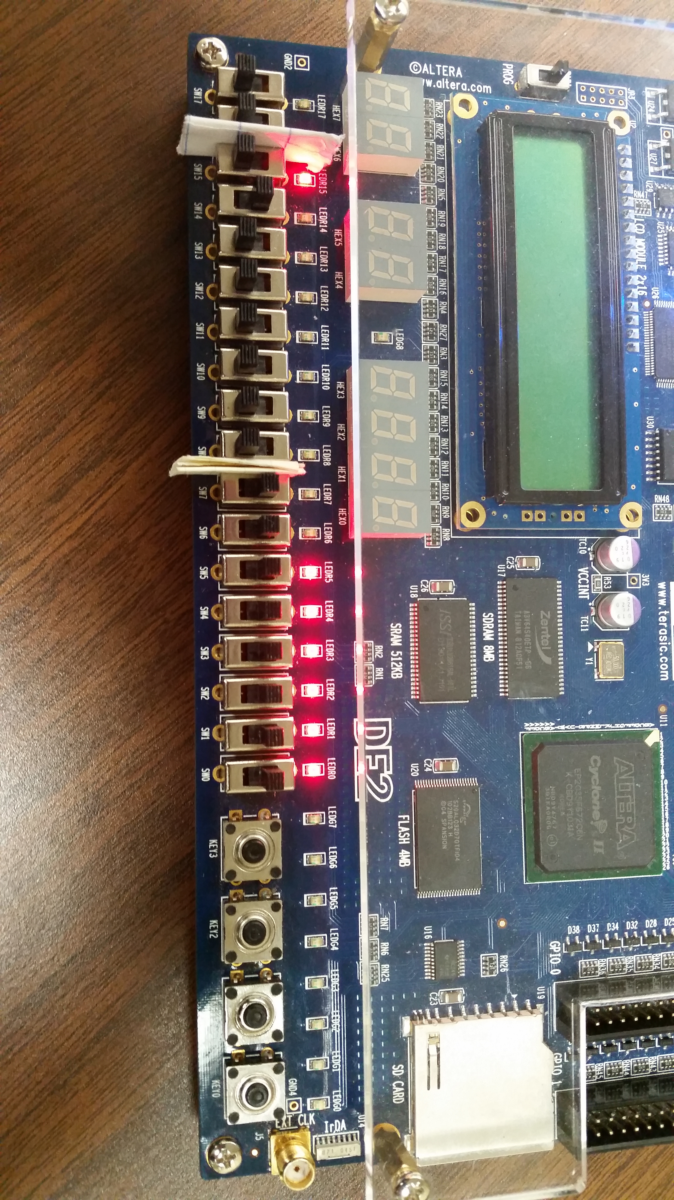

Fig. 38. 64 + (-1) = 63.

Fig. 38 shows the addition of 64 and -1. The eight bit adder/subtractor unit correctly outputs 63. Thus in the six figures above, we have demonstrated that the unit can take any two arbitrary eight bit binary numbers and output the correct sum, overflow, negative, and zero bits.

# Conclusion

In this lab I learned how the one-bit half and full adder are different. The half adder does not  
include the carry in while the full adder does include it. I created truth tables to extract the  
switching function of the sum and carry out. Although the circuit designs of the half and full adders are  
online, I made sure to verify the correctness of them using the truth table. I learned how to implement  
the data-flow and structural modeling of the full adder using the gates and half adder as a component. I  
also learned how to create test benches that looped through all the possible values to ensure that the  
circuit designs that I created in VHDL were correct. This is important because finding errors on the hardware is a lot harder when you have to manually turn on the switches. Most of my time was spent on writing a correct test bench. When that was done, implementing the designs on the DE2 board was a breeze.